Bangkok -Khaoyai 5day4NIGHT (PRIVATE)
Tour Highlight: Wat arun - PB valley Khaoyai – Sunflower filed -The Panora Camp& café -Primo Pizza - Hokkaido flower farm- Stardoi Farm Khoayai
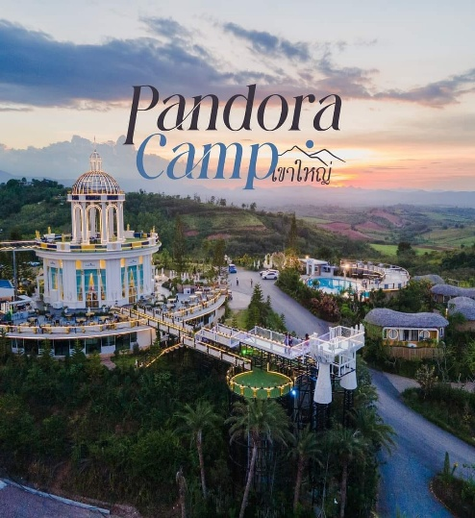
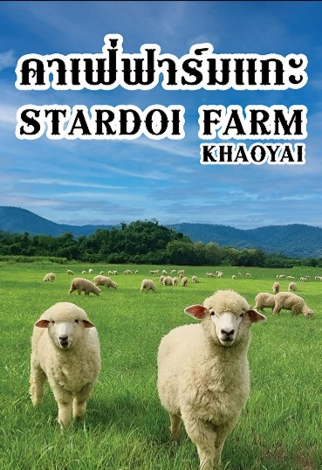
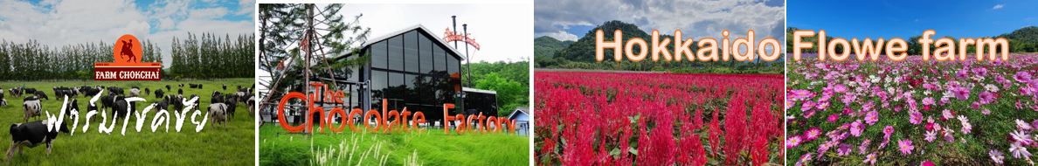

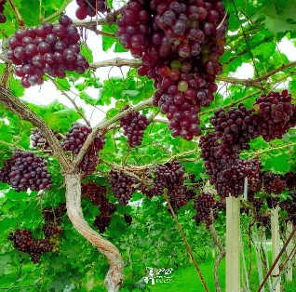
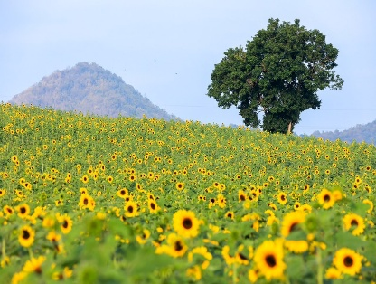
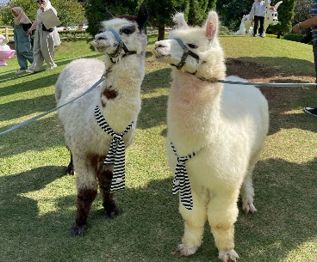

PB Valley Gape farm

Itinerary Tour Code: BKY-05

DAY 01 – KUALA LUMPUR – BANGKOK (No Meal)
- Assemble at International Airport for your flight to Bangkok. Upon arrival at Bangkok International Airport, meet and greet by our local representative and transfer to hotel check-in , Bantadthong or Joodfair Night street food, Dinner by own

DAY 02 – BANGKOK – KHAO YAI (Breakfast/Lunch/Dinner)
- PB Valley winery the largest winery in Thailand. Here, you will be able to take in the beautiful landscape of the vineyard. Scheduled and private wine tasting tour in PB Valley Estate is available upon request
- Primo Piazza: Succeeded in creating that warm and relaxing Mediterranean atmosphere, with an array of excellent cafes and restaurants on hand to help you unwind
- Hokkaido Flower Park Khao Yai is a flower field surrounded by mountains and nature. Although there are a dozen flower fields in Khao Yai, this particular one became one of the most popular spots
- Choolate factory & Café

DAY 03 – KHAO YAI (Breakfast/Lunch/Dinner)
- Sunflower filed: The season on Nov- Jan
- The Panora Camp – Enjoy a breathtaking panoramic view of Khao Yai.
- Star Doi sheep farm & Café he highlight is the opportunity to interact with many fluffy sheep in a scenic setting, which is somewhat unique for the Khao Yai region
- Pak Chong night market after back to hotel

DAY 4: KHAOYAI- BANGKOK (Breakfast/Lunch/Dinner by own)
After breakfast transfer to Bangkok approx. 3 hrs
- Visit Wat Arun (Temple of the Dawn) – one of Bangkok’s most iconic landmarks along the Chao Phraya River.
Explore some of Bangkok’s busiest and most vibrant areas, including ICONSIAM or the new Central Park shopping mall.
- In the evening, enjoy a visit to Asiatique The Riverfront, a lively open-air night market with restaurants, boutiques, and riverside views.

DAY 05 – BANGKOK / KUALA LUMPUR (Breakfast)
After breakfast, free for your last-minute shopping at the mall nearby.
Transfer to the Bangkok International Airport for your flight home. with sweet memories

